**Attaching all the output screenshots don’t during testing of the project in postman**

**Signup Endpoint**

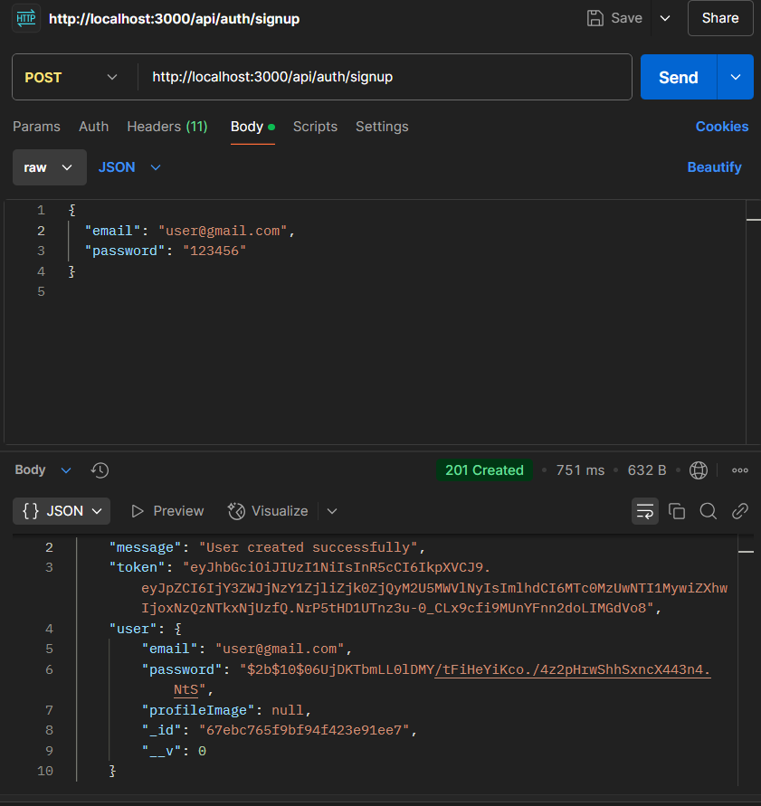

**Login EndPoint**

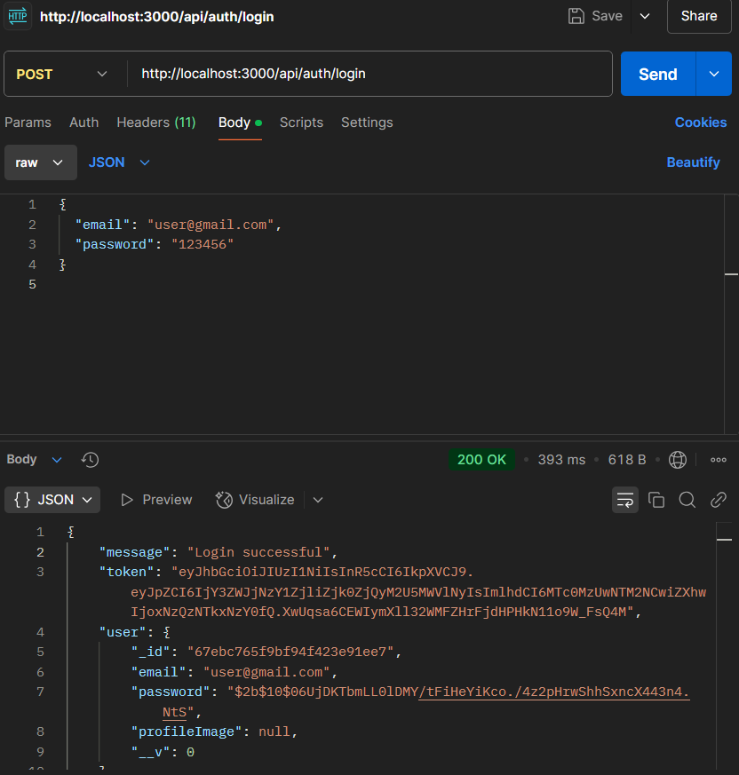

**Blog testing (creation EndPoint)**

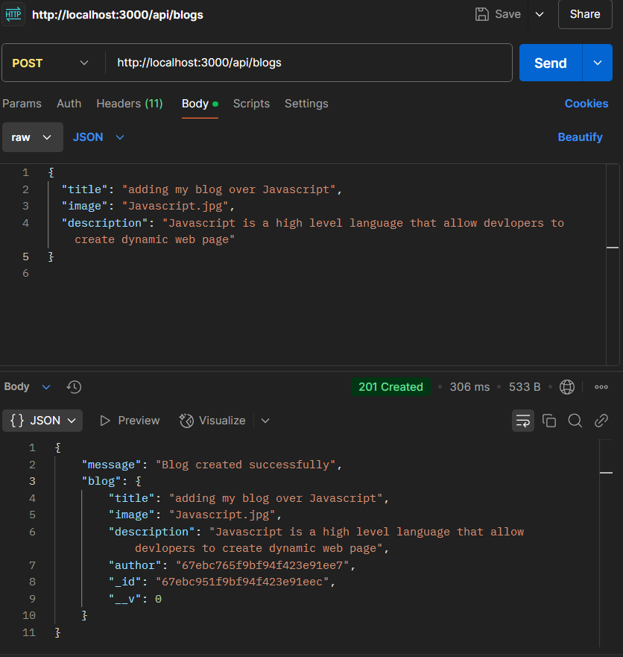

**Blog ( get all the blogs ) Endpoint**

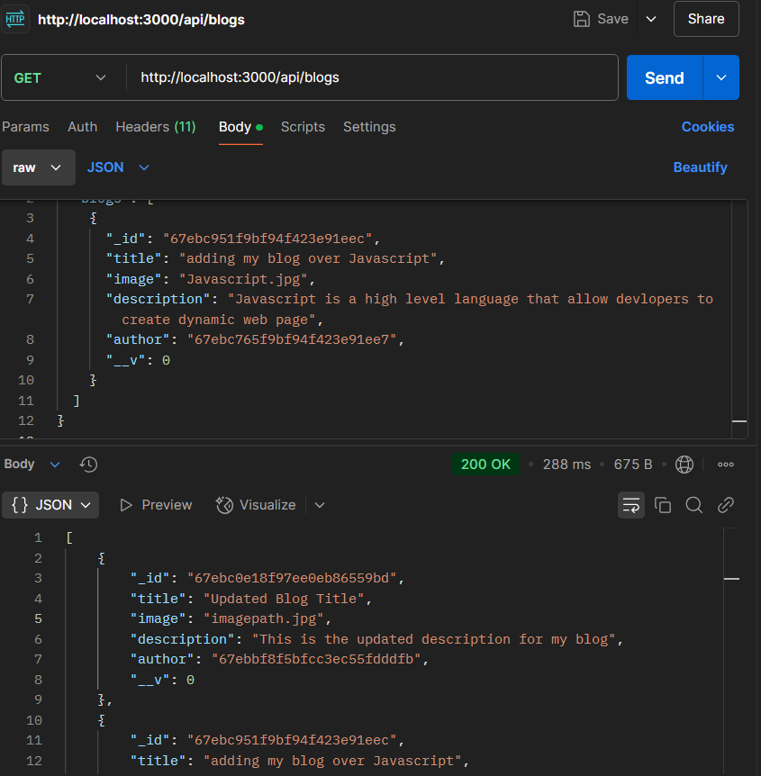

**Blog( updation ) Endpoint**

